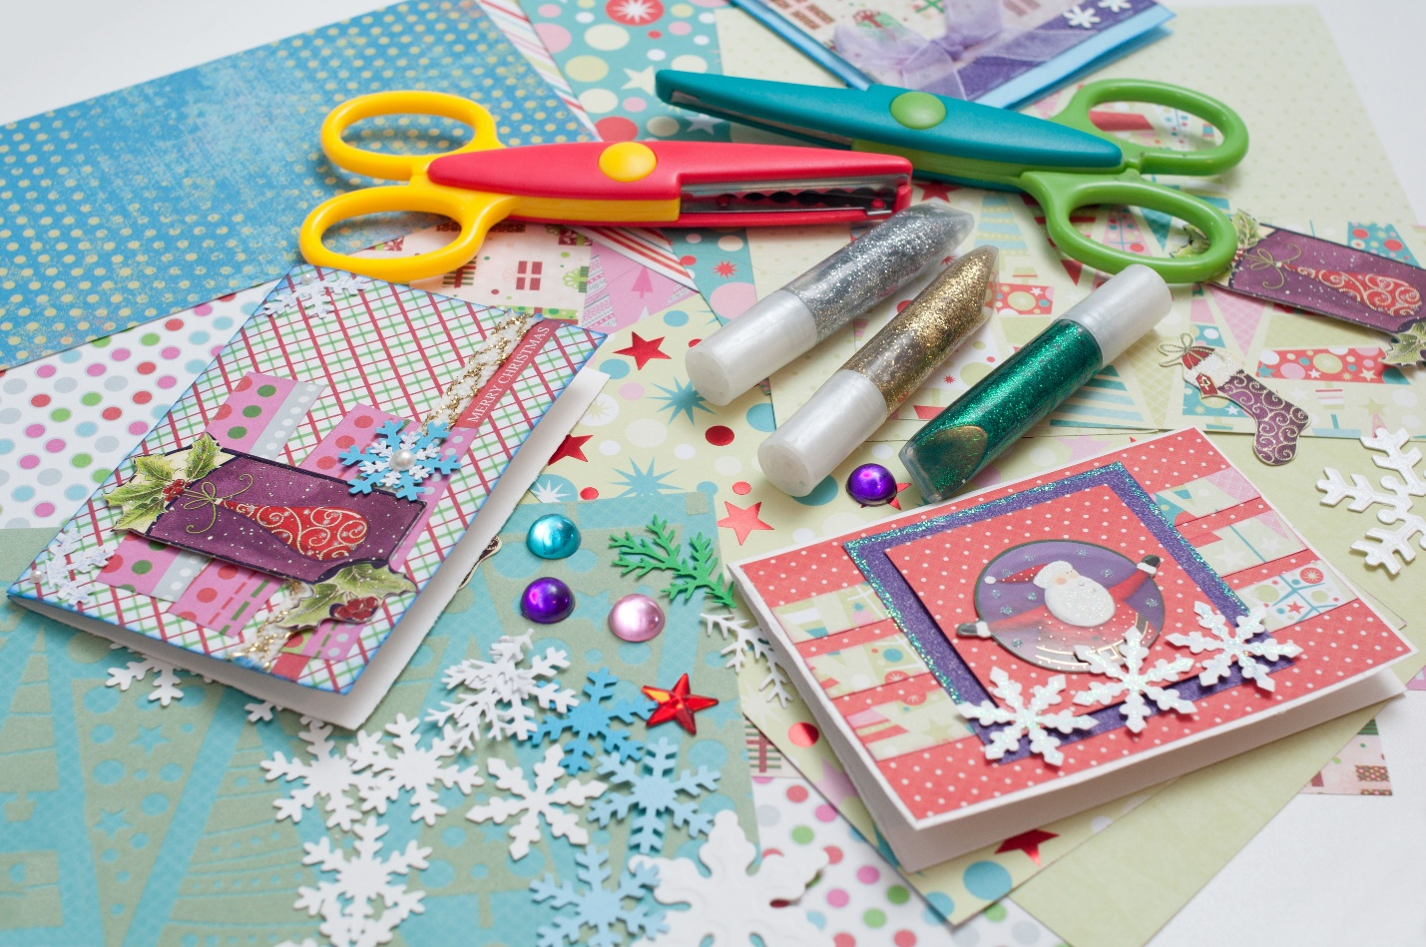

CARD MAKING!

Thursday, april 28th
1-2pm

FREE!

